1. Two Phase Flow
   1. Total Pressure Drop

$$∆P_{TP}=\frac{L}{D}\frac{{ G}^{2}}{2ρ_{TP}}$$

$$G=ρ_{f}u_{f}\left(1-α\right)+ρ_{g}u_{g}α$$

$$α=\frac{1}{1+\left(\frac{1-x}{x}\right)\frac{ρ_{g}}{ρ_{f}}}=\frac{Q_{g}}{Q_{g}+Q_{f}}$$

$$ρ_{TP}=ρ_{f}\left(1-α\right)+ρ_{g}α$$

$$Q_{f}=u_{f}\left(1-α\right)A_{f}, Q_{g}=u_{g}αA_{g}$$

$$Assuming: A_{f}=π{\left(\frac{D}{2}\right)}^{2}\frac{Q_{f}}{Q_{g}+Q_{f}}=π{\left(\frac{D}{2}\right)}^{2}\left(1-α\right), A_{g}=π{\left(\frac{D}{2}\right)}^{2}\frac{Q_{g}}{Q_{g}+Q_{f}}=π{\left(\frac{D}{2}\right)}^{2}α$$

$$∆P_{TP}=\frac{L}{D} \left(\frac{{\left(\frac{ρ_{f}Q_{f}}{A_{f}}+\frac{ρ_{g}Q_{g}}{A_{g}}\right)}^{2}}{2\left(ρ_{f}\left(1-α\right)+ρ_{g}α\right)}\right)=\frac{L}{D} \left(\frac{{\left(\frac{ρ_{f}(Q_{g}+Q_{f})}{π{\left(\frac{D}{2}\right)}^{2}}+\frac{ρ_{g}(Q_{g}+Q_{f})}{π{\left(\frac{D}{2}\right)}^{2}}\right)}^{2}}{2\left(ρ_{f}\left(1-\frac{Q_{g}}{Q_{g}+Q_{f}}\right)+ρ_{g}\frac{Q_{g}}{Q_{g}+Q_{f}}\right)}\right)$$

|  |  |  |
| --- | --- | --- |
| Air inlet flow rate [m^3/s] | Water inlet flow [m^3/s] | Pressure Drop [Pa] |
| 0.001 | 0.00020 | 42907.01 |
| 0.001 | 0.00040 | 34175.61 |
| 0.001 | 0.00080 | 36375.60 |
| 0.001 | 0.0020 | 67426.61 |
| 0.002 | 0.00020 | 262730.26 |
| 0.002 | 0.00040 | 171628.02 |
| 0.002 | 0.00080 | 136702.45 |
| 0.002 | 0.0020 | 159724.27 |
| 0.01 | 0.00020 | 24929022.36 |
| 0.01 | 0.00040 | 13620317.66 |
| 0.01 | 0.00080 | 7746197.91 |
| 0.01 | 0.0020 | 4290700.52 |

* 1. Total Pressure Drop as function of flow quality

$$∆P_{TP}=\frac{L}{D} \left(\frac{{\left(\frac{ρ_{f}Q_{f}}{π{\left(\frac{D}{2}\right)}^{2}\left(1-\frac{1}{1+\left(\frac{1-x}{x}\right)\frac{ρ_{g}}{ρ_{f}}}\right)}+\frac{ρ_{g}Q_{g}}{π{\left(\frac{D}{2}\right)}^{2}(\frac{1}{1+\left(\frac{1-x}{x}\right)\frac{ρ_{g}}{ρ_{f}}}) }\right)}^{2}}{2\left(ρ_{f}\left(1-\frac{1}{1+\left(\frac{1-x}{x}\right)\frac{ρ_{g}}{ρ_{f}}}\right)+ρ_{g}\frac{1}{1+\left(\frac{1-x}{x}\right)\frac{ρ_{g}}{ρ_{f}}}\right)}\right)$$

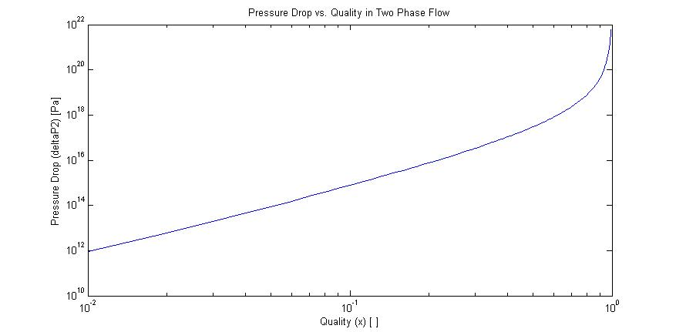

# Works Cited

Munson, Y. O. (2009). *Fundamentals of Fluid Mechanics.* Hoboken, NJ: Wiley and Sons, Inc.